Assignment


Name Aqsa perveen
Roll Number BCS-F24-E22
Assignment Computer Architenture
Teacher Name Sir Raza
Semester 5th(Self)
Department Computer Science

University of Mianwali

NASM Assembly Language Tasks
32-bit NASM Assembly for Windows
Task 1: Put a Number in a Register
global _main
extern _printf
section .data
; %d tells printf to display a decimal number.
; 10 creates a new line.
; 0 marks the end of the string.
format db "Value in AL = %d", 10, 0
section .text
_main:
; Put decimal 10 into AL.
; AL is an 8-bit register.
mov al, 10
; printf works with larger values.
; MOVZX copies AL into EAX and fills
; the remaining bits with zeros.
movzx eax, al
; Function parameters are pushed onto
; the stack from right to left.
push eax
; Push the address of the format string.
push format
; Call the printf function.
call _printf
; Two 32-bit values were pushed.
; Each value used 4 bytes.
; Remove 8 bytes from the stack.
add esp, 8
; Return 0 from the program.
xor eax, eax
ret
Resulting Output :
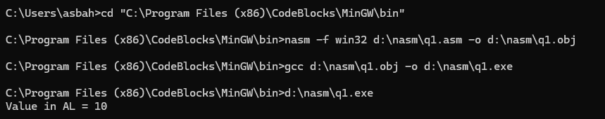
Task 2: Store a 32-Bit Number
global _main
extern _printf
section .data
; %08X displays an 8-digit hexadecimal value.
format db "EAX = 0x%08X", 10, 0
section .text
_main:
; EAX is a 32-bit CPU register.
; Store hexadecimal 12345678 inside it.
mov eax, 0x12345678
; Push the number that printf will display.
push eax
; Push the address of the format string.
push format
; Display the result.
call _printf
; Remove the two parameters from the stack.
add esp, 8
; Return 0.
xor eax, eax
ret

Resulting Output :

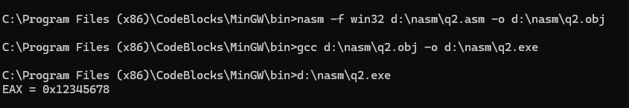

Task 3: Copy Data Between Registers
global _main
extern _printf
section .data
format db "AL = %d, BL = %d", 10, 0
section .text
_main:
; Store 10 inside AL.
mov al, 10
; Copy AL into BL.
mov bl, al
; Convert BL to a 32-bit value.
; Store it temporarily in ECX.
movzx ecx, bl
; Convert AL to a 32-bit value.
; Store it in EAX.
movzx eax, al
; printf arguments are pushed
; from right to left.
push ecx
push eax
push format
call _printf
; Three values were pushed.
; 3 x 4 = 12 bytes.
add esp, 12
xor eax, eax
ret

Resulting Output :
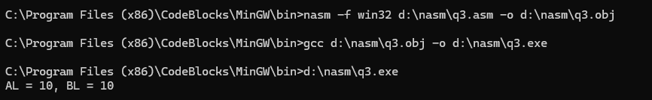

Task 4: Add a Number
global _main
extern _printf
section .data
format db "10 + 5 = %d", 10, 0
section .text
_main:
; Start with 10.
mov al, 10
; Add 5 to AL.
add al, 5
; AL now contains 15.
; Convert the 8-bit result to 32 bits.
movzx eax, al
push eax
push format
call _printf
add esp, 8
xor eax, eax
ret

Resulting Output :
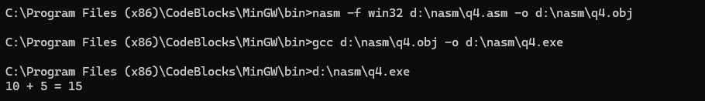

Task 5: Add Two Registers
global _main
extern _printf
section .data
format db "AL = %d, BL = %d", 10, 0
section .text
_main:
; Store 10 in AL.
mov al, 10
; Store 20 in BL.
mov bl, 20
; Add the contents of BL to AL.
add al, bl
; AL now contains 30.
; BL still contains 20.
movzx ecx, bl
movzx eax, al
push ecx
push eax
push format
call _printf
add esp, 12
xor eax, eax
ret

Resulting Output :
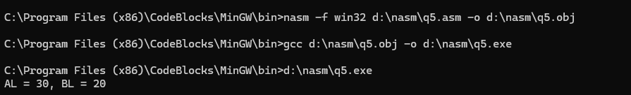

Task 6: Perform 32-Bit Addition
global _main
extern _printf
section .data
format db "EAX = %d, EBX = %d", 10, 0
section .text
_main:
; Store 10 inside EAX.
mov eax, 10
; Store 20 inside EBX.
mov ebx, 20
; Add EBX to EAX.
add eax, ebx
; EAX now contains 30.
; EBX still contains 20.
push ebx
push eax
push format
call _printf
add esp, 12
xor eax, eax
ret

Resulting Output :
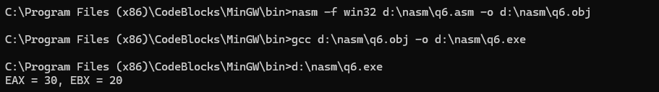

Task 7: Basic Subtraction
global _main
extern _printf
section .data
format db "20 - 5 = %d", 10, 0
section .text
_main:
; Store 20 inside AL.
mov al, 20
; Subtract 5.
sub al, 5
; AL now contains 15.
movzx eax, al
push eax
push format
call _printf
add esp, 8
xor eax, eax
ret

Resulting Output :
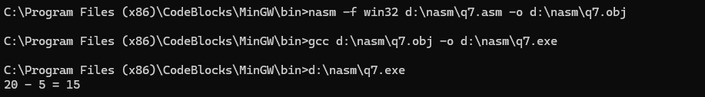

Task 8: Subtract One Register From Another
global _main
extern _printf
section .data
format db "30 - 10 = %d", 10, 0
section .text
_main:
mov eax, 30
mov ebx, 10
; Calculate EAX - EBX.
sub eax, ebx
; EAX now contains 20.
push eax
push format
call _printf
add esp, 8
xor eax, eax
ret
Resulting Output :

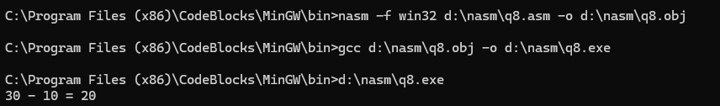

Task 9: Increment a Register
global _main
extern _printf
section .data
format db "After INC, EAX = %d", 10, 0
section .text
_main:
; Start with 9.
mov eax, 9
; INC means increase by one.
inc eax
; EAX now contains 10.
push eax
push format
call _printf
add esp, 8
xor eax, eax
ret
Resulting Output :
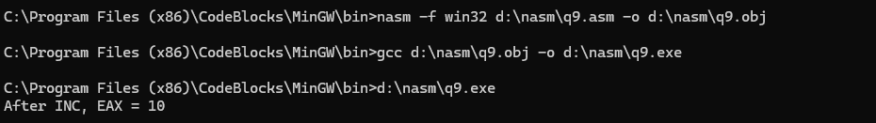

Task 10: Decrement a Register
global _main
extern _printf
section .data
format db "After DEC, EBX = %d", 10, 0
section .text
_main:
; Start with 10.
mov ebx, 10
; DEC means decrease by one.
dec ebx
; EBX now contains 9.
push ebx
push format
call _printf
add esp, 8
xor eax, eax
ret
Resulting Output :
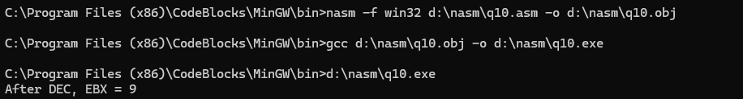

Task 11: Perform an AND Operation
global _main
extern _printf
section .data
format db "Result = 0x%02X", 10, 0
section .text
_main:
; AA in binary is:
; 10101010
mov al, 0xAA
; 0F in binary is:
; 00001111
and al, 0x0F
; Result:
; 00001010
; This is hexadecimal 0A.
movzx eax, al
push eax
push format
call _printf
add esp, 8
xor eax, eax
ret
Resulting Output :
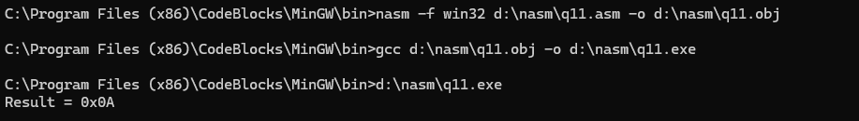

Task 12: Perform an OR Operation
global _main
extern _printf
section .data
format db "Result = %d", 10, 0
section .text
_main:
; Decimal 5:
; 00000101
mov al, 5
; Decimal 8:
; 00001000
or al, 8
; Result:
; 00001101
; Decimal 13.
movzx eax, al
push eax
push format
call _printf
add esp, 8
xor eax, eax
ret
Resulting Output :
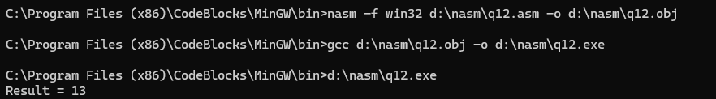

Task 13: Compare Two Equal Numbers
global _main
extern _printf
section .data
equalMessage db "The numbers are equal.", 10, 0
notEqualMessage db "The numbers are not equal.", 10, 0
section .text
_main:
mov al, 10
mov bl, 10
; CMP internally performs:
; AL - BL
; The result is not stored.
; CPU flags are updated instead.
cmp al, bl
; JE means Jump if Equal.
; It checks the Zero Flag.
je numbers_are_equal
numbers_are_not_equal:
push notEqualMessage
call _printf
add esp, 4
jmp finished
numbers_are_equal:
push equalMessage
call _printf
add esp, 4
finished:
xor eax, eax
ret
Resulting Output :
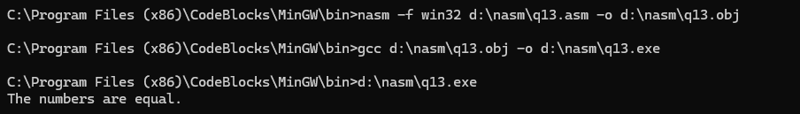

Task 14: Test Two Bit Patterns
global _main
extern _printf
section .data
zeroMessage db "No common 1 bits were found.", 10, 0
commonMessage db "Common 1 bits were found.", 10, 0
section .text
_main:
; AL = 11110000
mov al, 0xF0
; BL = 00001111
mov bl, 0x0F
; TEST performs a bitwise AND
; but does not save the answer.
; It only changes CPU flags.
test al, bl
; Jump if the result was zero.
jz no_common_bits
common_bits:
push commonMessage
call _printf
add esp, 4
jmp finished
no_common_bits:
push zeroMessage
call _printf
add esp, 4
finished:
xor eax, eax
ret
Resulting Output :
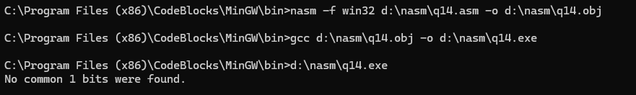

Task 15: Exchange Two Registers
global _main
extern _printf
section .data
format db "AL = %d, BL = %d", 10, 0
section .text
_main:
mov al, 10
mov bl, 20
; Before XCHG:
; AL = 10
; BL = 20
xchg al, bl
; After XCHG:
; AL = 20
; BL = 10
movzx ecx, bl
movzx eax, al
push ecx
push eax
push format
call _printf
add esp, 12
xor eax, eax
ret

Resulting Output :
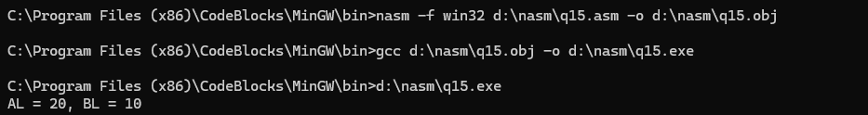

Task 16: Store a Number in Memory
global _main
extern _printf
section .data
; Reserve one byte in memory.
; Its starting value is 0.
number db 0
format db "Value in memory = %d", 10, 0
section .text
_main:
; Store decimal 42 at the memory
; location called number.
mov byte [number], 42
; Read the byte from memory and
; convert it to a 32-bit value.
movzx eax, byte [number]
push eax
push format
call _printf
add esp, 8
xor eax, eax
ret

Resulting Output :
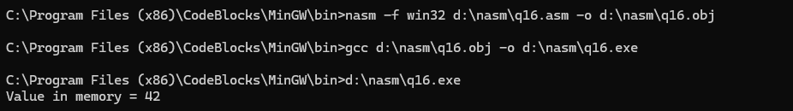

Task 17: Read Data From Memory
global _main
extern _printf
section .data
number db 0
format db "Value loaded into BL = %d", 10, 0
section .text
_main:
; Store 42 in memory.
mov byte [number], 42
; Read the byte from memory
; and place it inside BL.
mov bl, [number]
; Convert BL to 32 bits for printf.
movzx eax, bl
push eax
push format
call _printf
add esp, 8
xor eax, eax
ret

Resulting Output :
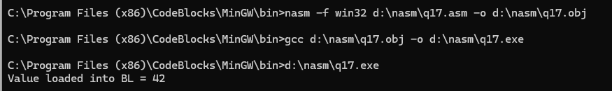

Task 18: Add a Register Value to Memory
global _main
extern _printf
section .data
; Create one byte containing 10.
number db 10
format db "New memory value = %d", 10, 0
section .text
_main:
; Put 5 into BL.
mov bl, 5
; Add BL to the byte stored in memory.
;
; Memory initially contains 10.
; BL contains 5.
;
; 10 + 5 = 15
add byte [number], bl
; Read the new memory value.
movzx eax, byte [number]
push eax
push format
call _printf
add esp, 8
xor eax, eax
ret
Resulting Output :
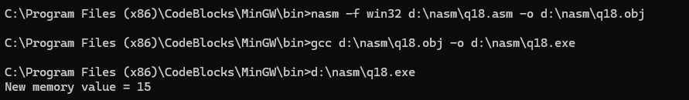

Task 19: Use the Stack
global _main
extern _printf
section .data
format db "EAX = 0x%08X, EBX = 0x%08X", 10, 0
section .text
_main:
; Put a value into EAX.
mov eax, 0x12345678
; PUSH places EAX on the stack.
push eax
; POP removes the top value
; from the stack and places it
; inside EBX.
pop ebx
; Both registers now contain
; the same value.
push ebx
push eax
push format
call _printf
add esp, 12
xor eax, eax
ret
Resulting Output :
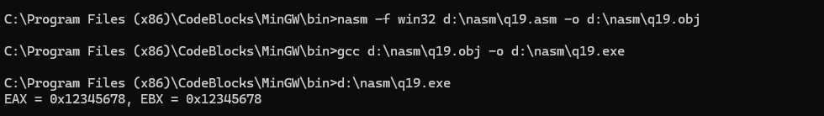

Task 20: Mini Complete Program
global _main
extern _printf
section .data
; Reserve one byte for the final result.
result db 0
; printf will display three decimal numbers.
format db "AL = %d, BL = %d, Memory = %d", 10, 0
section .text
_main:
; -------------------------------------------------
; Step 1
; Put 10 into AL.
; -------------------------------------------------
mov al, 10
; -------------------------------------------------
; Step 2
; Add 20.
;
; 10 + 20 = 30
; -------------------------------------------------
add al, 20
; -------------------------------------------------
; Step 3
; Subtract 5.
;
; 30 - 5 = 25
; -------------------------------------------------
sub al, 5
; -------------------------------------------------
; Step 4
; Store AL in memory.
;
; Memory now contains 25.
; -------------------------------------------------
mov [result], al
; -------------------------------------------------
; Step 5
; Read the value from memory into BL.
; -------------------------------------------------
mov bl, [result]
; -------------------------------------------------
; Prepare values for printf.
;
; printf uses 32-bit integer parameters.
; -------------------------------------------------
movzx eax, al
movzx ecx, bl
movzx edx, byte [result]
; -------------------------------------------------
; printf arguments must be pushed
; from right to left.
;
; format contains:
;
; AL = %d, BL = %d, Memory = %d
;
; Therefore we push:
;
; Memory
; BL
; AL
; format address
; -------------------------------------------------
push edx
push ecx
push eax
push format
call _printf
; -------------------------------------------------
; Four 32-bit parameters were pushed.
;
; 4 x 4 bytes = 16 bytes.
;
; Restore ESP.
; -------------------------------------------------
add esp, 16
; -------------------------------------------------
; Return 0 to Windows.
; -------------------------------------------------
xor eax, eax
ret
Resulting Output :
